EC-444 Parallel & Distributed Computing
BS (CE)-2020
Semester Project Report



Submitted By:
Reg. No. | Name
20-CE-035 | Abdullah Javed

Department of Computer Engineering
HITEC University Taxila

___________________________
Submitted To:
Engr. Fasih Ahmad
Contents
Implementation of the 2D-Convolution in CUDA C 4
Problem Statement: 4
Tools Used: 4
Algorithm: 5
Parallelization Strategy: 7
Version 1 (Serial): 7
Version 2 (Open MP): 7
Version 3 (CUDA): 7
Detailed Profile & Analysis: 8
Version 1: 8
Version 2: 8
Version 3: 9
Comparison Between Version 1 & Version 2: 9
Comparison Between Version 2 & Version 3: 10
Execution Time & Speed up Results: 11
Speedup From Version 1 to Version 2: 11
Speedup From Version 2 to Version 3: 11
Speedup from Serial to CUDA Version: 11
Conclusion: 12

Table of Figures
Figure 1 image matrix x and kernel h 5
Figure 2 Inversion of h matrix 5
Figure 3 Convolution of pixels Row by Row 5
Figure 4 Resultant Matrix 6
Figure 5 Serial Execution Time 8
Figure 6 Parallel Execution Time Using OMP 8
Figure 7 GPU Execution Time 9

Implementation of the 2D-Convolution in CUDA C

Problem Statement:
Convolution is the most important and fundamental concept in signal processing and analysis. Convolution is the process of adding each element of the image to its local neighbors, weighted by the kernel. Mathematically, it describes a rule of how to combine two functions or pieces of information to form a third function. The feature map (or input data) and the kernel are combined to form a transformed feature map. The convolution algorithm is often interpreted as a filter, where the kernel filters the feature map for certain information.

Tools Used:
- Linux Ubuntu
- GCC/G++ Compiler
- OpenMP
- CUDA
- “Timer.h” (For Profiling)

Algorithm:
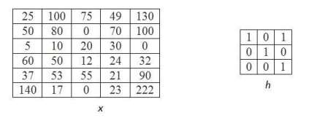
Figure 1 image matrix x and kernel h

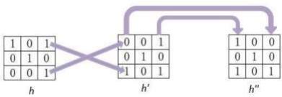
Figure 2 Inversion of h matrix

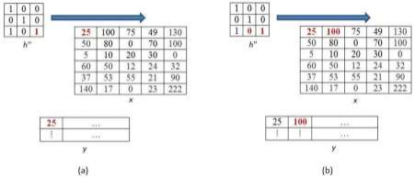
Figure 3 Convolution of pixels Row by Row
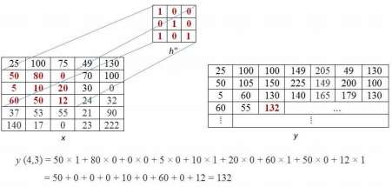
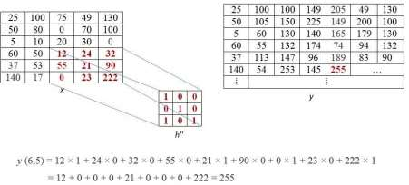

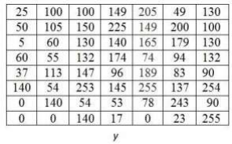
Figure 4 Resultant Matrix

Parallelization Strategy:

Version 1 (Serial):
We need to initialize the convolution kernel with the desire or some random values. Also, if we want to print the output matrix, we can do it through a nested for loop.
We will include all the necessary libraries for this operation. For larger images or more computationally intensive tasks, parallel execution using techniques like multithreading or GPU acceleration may provide significant performance improvements.

Version 2 (Open MP):
To parallelize the convolution operation, we will parallelize the loop. I added the #pragma omp parallel for directive just before the outer loop. This directive instructs OpenMP to distribute the iterations of the loop across multiple threads for parallel execution. We just have to make sure that OpenMP is installed and the library in included in the source file.

Version 3 (CUDA):
In this version, we have a convolutionKernel function that performs the 2D convolution operation on the GPU. Each thread in the CUDA thread block loads a portion of the input image and the convolution kernel into shared memory. It then performs the convolution operation and stores the result in the output image.
In the main function, we allocate memory on the host and the device, initialize the input image with random values, and copy it from the host to device. We define the grid and block dimensions based on the image size and the specified block size. Finally, we launch the convolutionKernel function on the GPU, copy the output image from the device to the host, and print the first few elements of the output for verification.
We need to make sure that we have an Nvidia GPU in the system and install the CUDA Toolkit before running this program.

Detailed Profile & Analysis:

Version 1:
We have used the Timer.h header file for profiling. We simply initialize a timer variable which will store the execution time. Start the timer before calling the convolution function and end the timer after the execution. Finally, we just print the execution time.
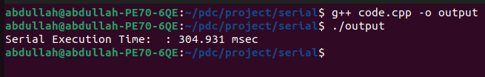
Figure 5 Serial Execution Time

Version 2:
We have followed the same procedure for profiling as in version 1. Include Timer.h library, start and end the timer before and after the function call for the convolution.
I have tested parallel execution with 2, 4, 6 and 8 threads to see which one gives the best performance.
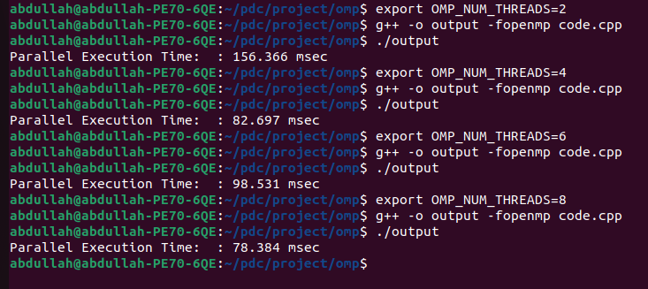
Figure 6 Parallel Execution Time Using OMP

Version 3:
Simple include the Timer.h library and start and end the timer before and after the convolutionKernel call.
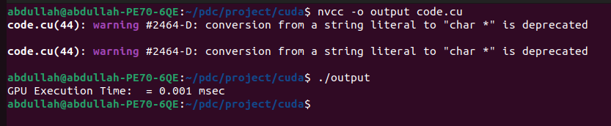
Figure 7 GPU Execution Time

Comparison Between Version 1 & Version 2:
Version 1 was the Sequential version of the convolution program, and Version 2 was the Parallel version of the same program. Both have been executed on CPU. The Following figure will give us a comparison between the performances of the two versions:

The best results have been achieved using 8 Threads

Comparison Between Version 2 & Version 3:
Version 2 was the parallel version for convolution using OpenMP and Version 3 was the GPU or CUDA version for the same program. The following figure will give us a comparison between the performances of the two versions:

CUDA gives such a huge performance improvement

Execution Time & Speed up Results:
Versions | Execution Times
Version 1 | 304.931 msec
Version 2 | 30.487 msec (best)
Version 3 | 0.001 msec

Speedup From Version 1 to Version 2:
Speed up = Execution Time (old) / Execution Time (new)
Speed up = 304.931 / 30.487
Speed up = 10.002

Speedup From Version 2 to Version 3:
Speed up = 30.487 / 0.001
Speed up = 30,487

Speedup from Serial to CUDA Version:
Speed up = 304.931 / 0.001
Speed up = 304,931

Conclusion:
We have implemented many possible execution strategies like sequential, parallel with 2, 4, 6 and 8 Threads on CPU and execution on GPU. After testing all of the methods, repetitive profiling and testing, calculating Speedup, we have come to the conclusion that GPU adds exponential increase in a machine’s performance. The graphs show that multithreading on CPU is good, but it is no way near as fast as GPU, because the GPU has a much greater number of cores & threads as compared to a CPU.

